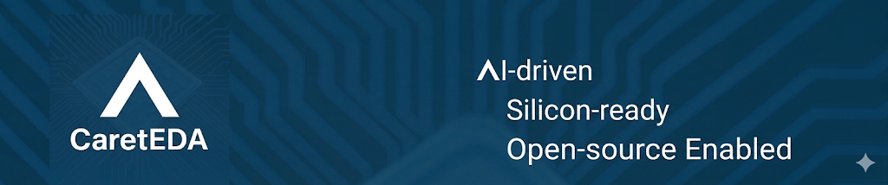
About the Company
Semiconductors are becoming the foundation of every major technological leap—from AI to energy to autonomy. The chip design community is standing at a rare inflection point, where decades of incremental progress are giving way to a new era shaped by AI native workflows, open ecosystems and open-source EDA which has matured into a powerful force, with real capabilities across simulation, logic synthesis, physical design, and verification.
But the next wave of exponential productivity acceleration won’t come from isolated tools. It will come from end to end, AI first design systems that learn your flow, protect your IP, scale with your team, and continuously accelerate the path from idea to silicon. That belief is the North Star behind CaretEDA.
We are an Agentic-first organization and full believers in bringing the power of agentic AI to EDA. We are 100% hands-on. And we measure success in the only way that matters: how many customers we make successful.
We’re here to prove that bright minds with shared purpose can reshape entire industries. If you’re looking to make a real impact in this one, read on. If you are ready to take the next step, send us your resume at ‘careers@careteda.com’.
About the Role
Senior Hardware Design & Verification Engineers (Bengaluru)
Customer-Facing • RTL + Simulation • AI-Assisted EDA • Spec-to-Netlist™ Deployment
CaretEDA is seeking Senior Hardware Design & Verification Engineers in Bangalore who will work directly with customers adopting our Spec-to-Netlist™ AI-native design platform.
This role blends deep technical understanding (RTL, simulation, chip development) with customer-facing clarity, helping engineering teams integrate, validate, and scale AI-assisted design workflows inside their existing environments.
You will collaborate with global engineering, product, and customer teams to ensure smooth deployments, build reproducible debug scenarios, and help customers get the most out of CaretEDA’s multi-agent, AI-driven design flows.

Key Responsibilities
Customer Deployment & Technical Guidance
Work closely with customer design and DV teams to integrate Spec-to-Netlist into their existing flows. Understand customer architecture specs, RTL conventions, verification environments, and toolchains. Help customers structure their inputs (specs, constraints, design intent) for optimal AI-assisted generation. Provide hands-on support during onboarding, pilot projects, and production rollouts.
Simulation & Debug Expertise
Reproduce customer issues using event-driven/cycle-based simulators and synthesis tools. Build minimal, shareable testcases to isolate tool behavior or AI-generated RTL issues. Analyze waveforms, debug corner cases, and validate correctness of tool behavior.
Champion AI-Assisted EDA Workflows
- Use AI-based tools to accelerate RTL review and comprehension, Testbench generation, Debug and root-cause analysis, Coverage exploration etc.
- Provide structured feedback to improve AI-assisted flows and automation quality.
Open-Source Ecosystem Fluency
- Navigate and understand large public SystemVerilog codebases such as OpenTitan, Ibex, SweRV, etc. Build clean, shareable debug environments.
Customer Collaboration & Communication
- Work directly with customers to understand their design/verification challenges. Provide clear, structured guidance and help them adopt AI-assisted workflows. Communicate technical findings effectively to both engineers and managers.

Required Qualifications
- BTech/MTech/MS in EE/CE/CS or related field.
- 5–10 years of experience in RTL design, simulation, or mixed design-DV roles.
- Strong SystemVerilog skills (design + testbench familiarity).
- Hands-on experience with at least one major commercial simulator.
- Solid understanding of the full chip development process.
- Excellent communication skills and ability to work with global teams.

Preferred Qualifications
- Experience with RISC-V or open-source silicon projects.
- Understanding of GenAI and Agentic flow; hands-on experience a big advantage
- Exposure to linting, synthesis, or formal verification.
- Experience with AI-assisted EDA tools or automation frameworks.
- Ability to create clean, reproducible testcases and debug environments.
- Prior customer-facing or cross-functional experience.
Apply by sending your resume to ‘careers@careteda.com’

